HACKATHON 03 DAY03

API-INTEGRATION AND DATA-MIGRATION

* **API Integration and Data Migration in Sanity with a Next.js Project**
* Sanity.io is a powerful content platform that enables structured content management. When integrating it with a Next.js project, understanding API integration and data migration is crucial for seamless functionality. This guide will walk you through both processes.
* **API Integration in Sanity with Next.js**
* Sanity provides a flexible JavaScript and REST API for interacting with its backend. Next.js is an ideal framework to consume Sanity's data due to its server-side rendering capabilities and dynamic routing.

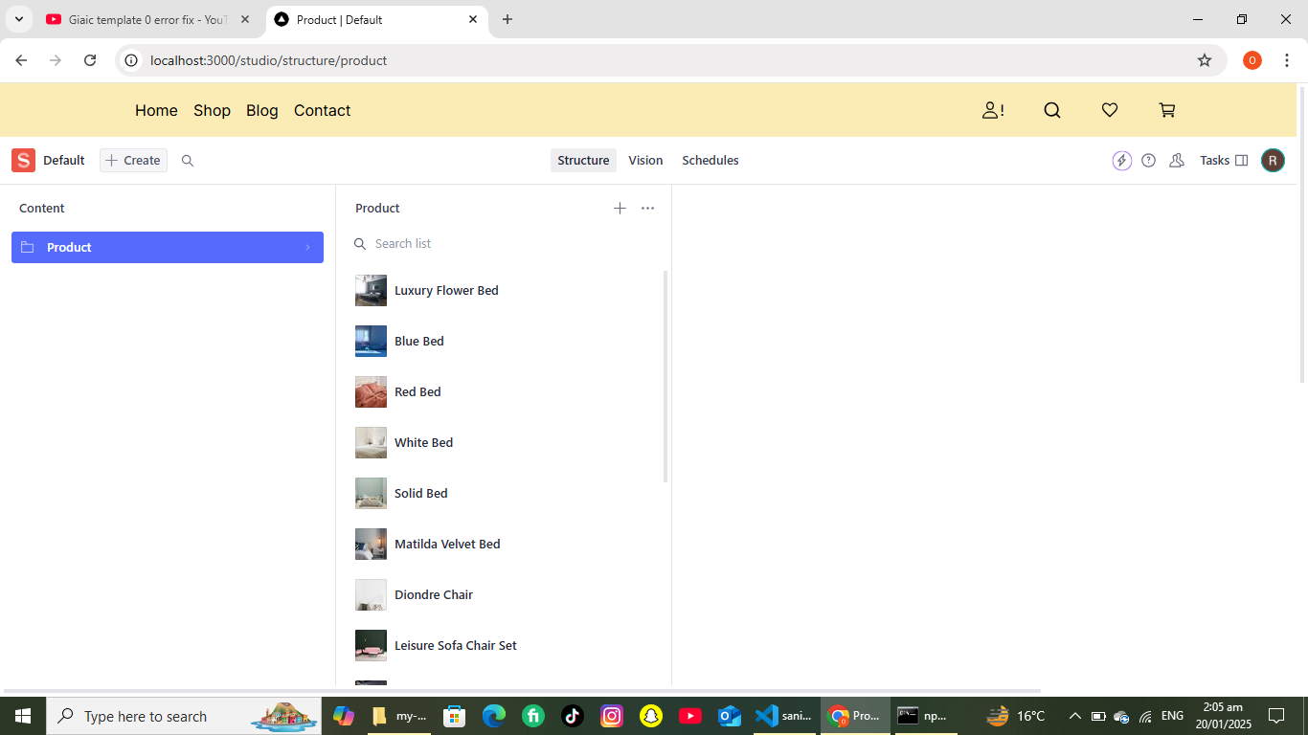

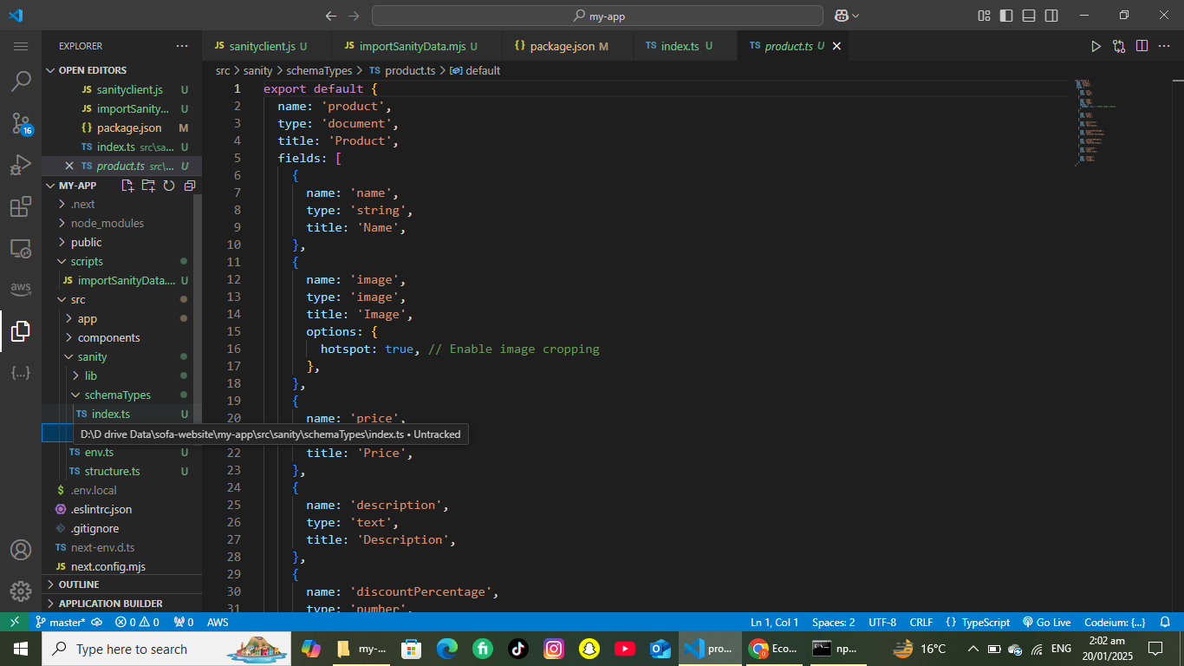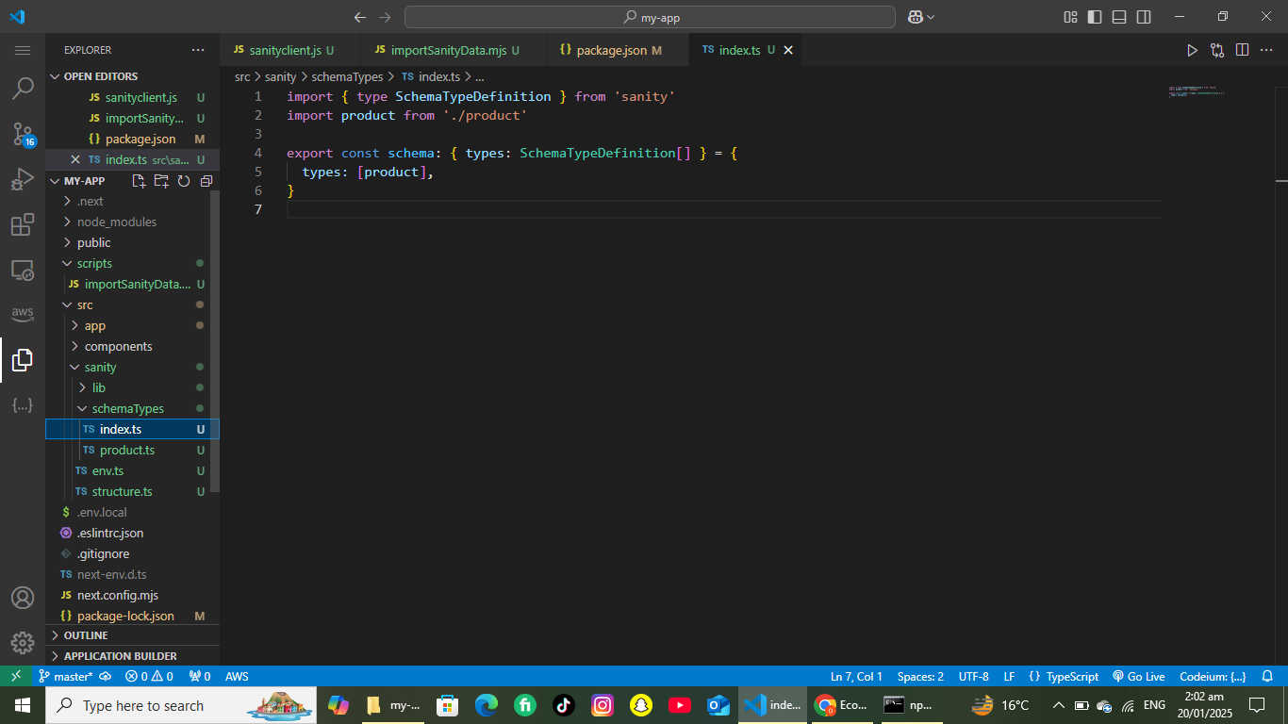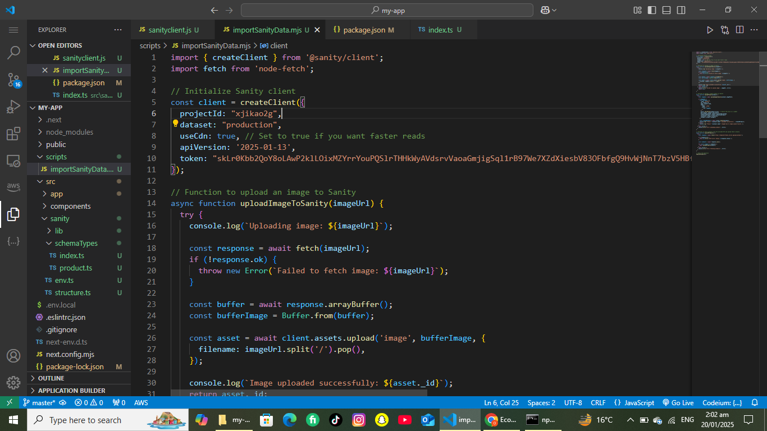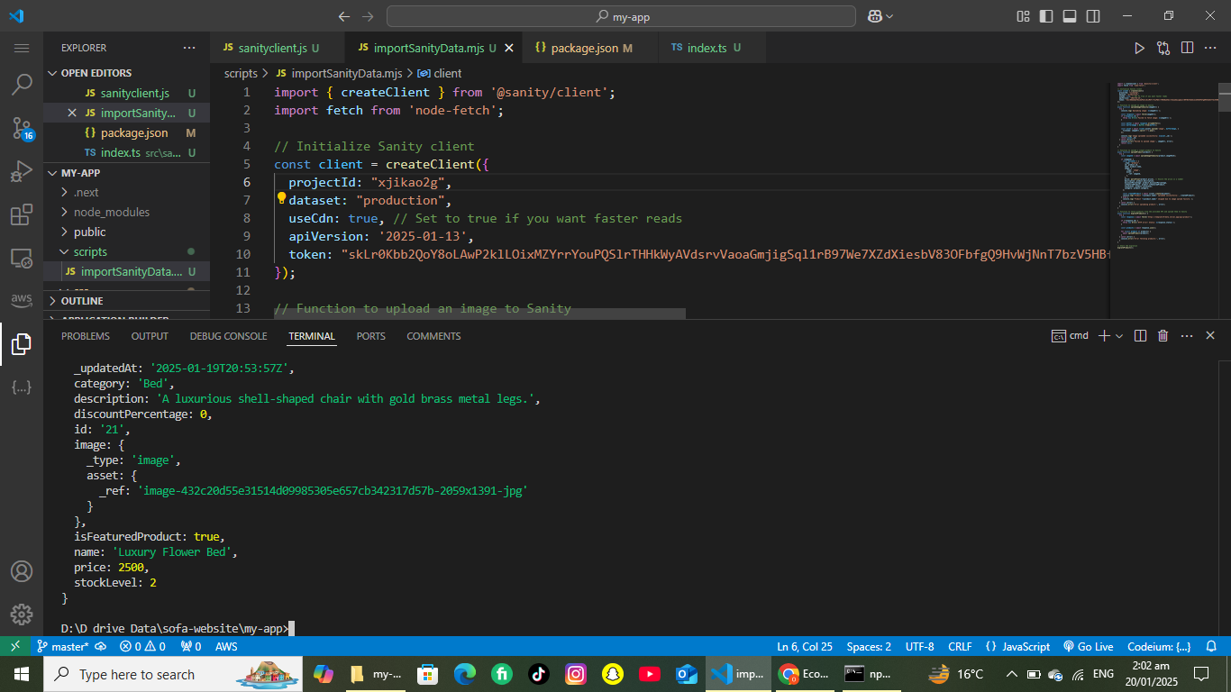

**Data Migration in Sanity**

When working with Sanity, migrating data from one project to another or importing existing datasets is a common task. Sanity’s CLI makes this process straightforward.

**1. Exporting Data**

**1. Importing Data**

**3. Handling Schema Changes**

**4. Validating and Transforming Data**